Good afternoon Srinivas,

My colleague, Jessica Eaves, who you spoke with yesterday passed along your request for the following estimates (please note, all estimates are based on a 60 day lock; a discount point is prepaid interest that you pay at closing for a lower interest rate, often referred to as “buying down” the interest rate):

1. No discount points, monthly PMI
2. Discount points, monthly PMI
3. No discount points, paying your PMI in full at closing
4. 3/2/1 buydown:  The cost would approximately be $22,217.52 based on a 7.250% note rate.  For the first year your payment would be based on an interest rate of 4.250%, the second year 5.250%, the third year 6.250% and then 7.250% for the remaining life of the loan.  This is what the principal & interest payments would look like:

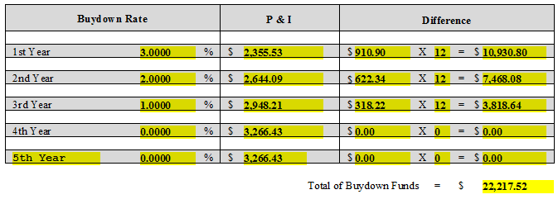

To know what the estimated total monthly payments would be you would want to add homeowners insurance ($156.04), property taxes ($1,226.50) and PMI ($103.75) for a total of $1,486.29 to each of the above P&I amounts

1. 2/1 buydown:  The cost would approximately be $11,286.72 based on a 7.250% note rate.  For the first year your payment would be based on an interest rate of 5.250%, the second year 6.250% and then 7.250% for the remaining life of the loan.  This is what the principal & interest payments would look like:

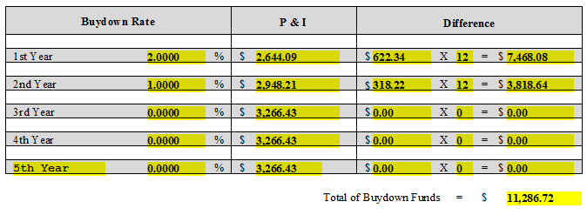

To know what the estimated total monthly payments would be you would want to add homeowners insurance ($156.04), property taxes ($1,226.50) and PMI ($103.75) for a total of $1,486.29 to each of the above P&I amounts

Please review at your earliest convenience and let me know if you have any questions or comments.

Kindest Regards,